MORE QUERIES ON BANK DATABASE
1) Find all the customers who have an account at all the branches
located in a specific city (Ex. Delhi).
A) select distinct s.customername
from depositer s
where not exists (
select 1
from branch br
where br.branch_city = 'delhi'
and br.branch_name not in (
select b.branch_name
from depositer t
join bankaccount b on t.accno = b.accno
where t.customername = s.customername));

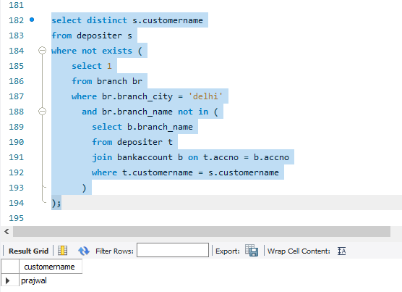

2) Find all customers who have a loan at the bank but do not have
an account.
A) select distinct lc.customername
from loancustomer lc
where lc.customername not in (
select d.customername
from depositer d );
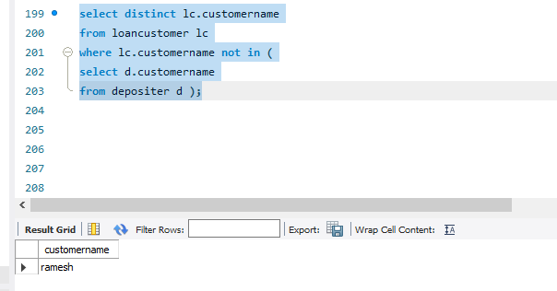

3) Find the names of all branches that have greater assets
than all branches located in Bangalore.
A) select branch_name
from branch
where assets > all (
select assets
from branch
where branch_city = 'bangalore');
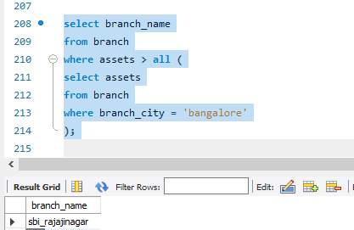

4) Find all customers who have both an account and a
loan at the Bangalore branch
A) select distinct lc.customername
from loancustomer lc
join loan l on lc.loan_number = l.loan_number
join branch br on l.branch_name = br.branch_name
where br.branch_city = 'bangalore'
and (l.branch_name, lc.customername) in (
select ba.branch_name, d.customername
from depositer d
join bankaccount ba on d.accno = ba.accno);

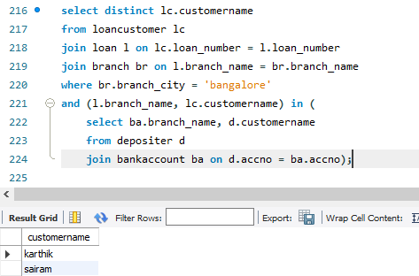
5) Update the Balance of all accounts by 5%
A) update bankaccount
set balance = balance * 1.05;

select * from bankaccount;
